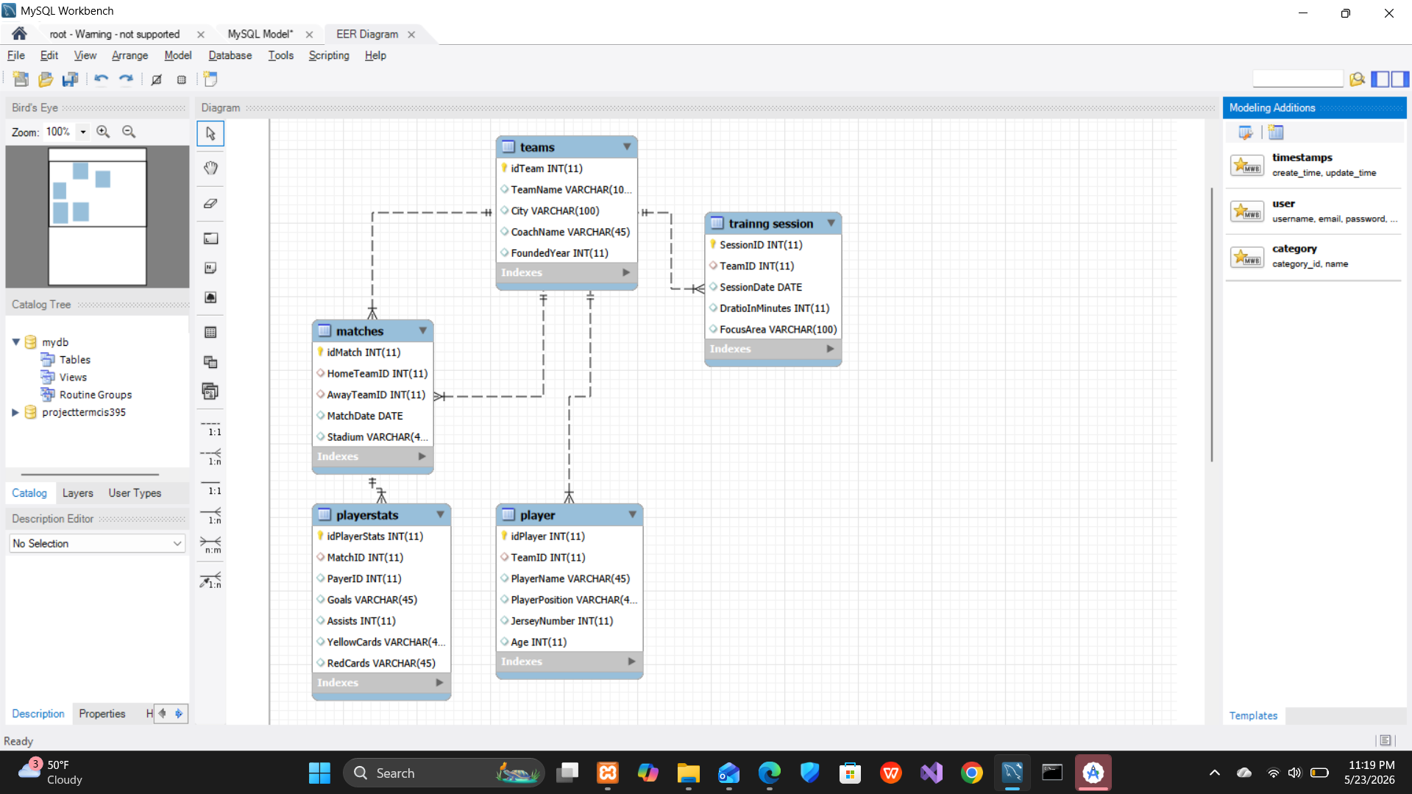

• ✅ ER Model table showing all 4 tables with attributes, PKs and FKs
• ✅ Step-by-step Workbench instructions for ER design and Forward Engineering
• ✅ INSERT script with sample records for all tables
• ✅ UPDATE script modifying dates, emails, and genres
• ✅ DELETE script removing loans, books, and members
• ✅ Export instructions for generating CIS395.sql
• ✅ Summary of deliverables (a, b, c, d)

